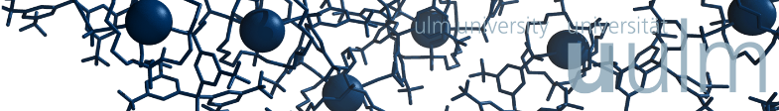
Max von Delius
The Dynamic Chemistry of Orthoesters
Institute of Organic Chemistry and Advanced Materials, University of Ulm, Germany. www.deliusgroup.net, max.vondelius@uni-ulm.de

Dynamic covalent chemistry (DCC) is a powerful tool for probing non-covalent interactions, identifying ligands for medicinally relevant biological targets, and for making use of the feature of “error correction” to achieve the synthesis of interesting molecules, porous materials, gels and polymers.

I will present our recent work on a new class of self-assembled, yet tiny cage compounds.¹ We were able to employ acid-catalyzed orthoester exchange² (Figure a) for the one-pot synthesis of cryptates, in which O,O,O-orthoesters act as tripodal bridgeheads. Due to their unique structure (see Figure b), these compounds exhibit a range of unusual properties,³ and preliminary studies point towards a broad scope of the self-assembly process. Most notably, dynamic orthoester cryptands offer an elegant entry to experiments, in which a metal ion selects its preferred host from a dynamic mixture of competing subcomponents (“adaptive host-guest systems”). We found that certain alkali metal ions directed the dynamic system towards the formation of one preferred host with remarkable selectivity, thus allowing us to carry out an unprecedented “cryptate metathesis” reaction (Figure c).⁴

Finally, I will discuss possible applications of this new class of compounds, as well as ongoing projects on related orthoester-based (supramolecular) architectures, including receptors for anions.

1. R.-C. Brachvogel, F. Hampel, M. von Delius, Nature Commun. 2015, 6, 7129.
2. R.-C. Brachvogel, M. von Delius, Chem. Sci. 2015, 6, 1399.
3. R.-C. Brachvogel, H. Maid, M. von Delius, Int. J. Mol. Sci. 2015, 16, 20641.
4. O. Shyshov, R.-C. Brachvogel, T. Bachmann, R. Srikantharajah, D. Segets, F. Hampel, R. Puchta, M. von Delius Angew. Chem. Int. Ed., 2017, 56, 776.

